LAB SESSION 1

Programming Exercise:

Question 1: Calculate Area of a Rectangle: Write a C++ program to calculate the area of a rectangle given its length and width.
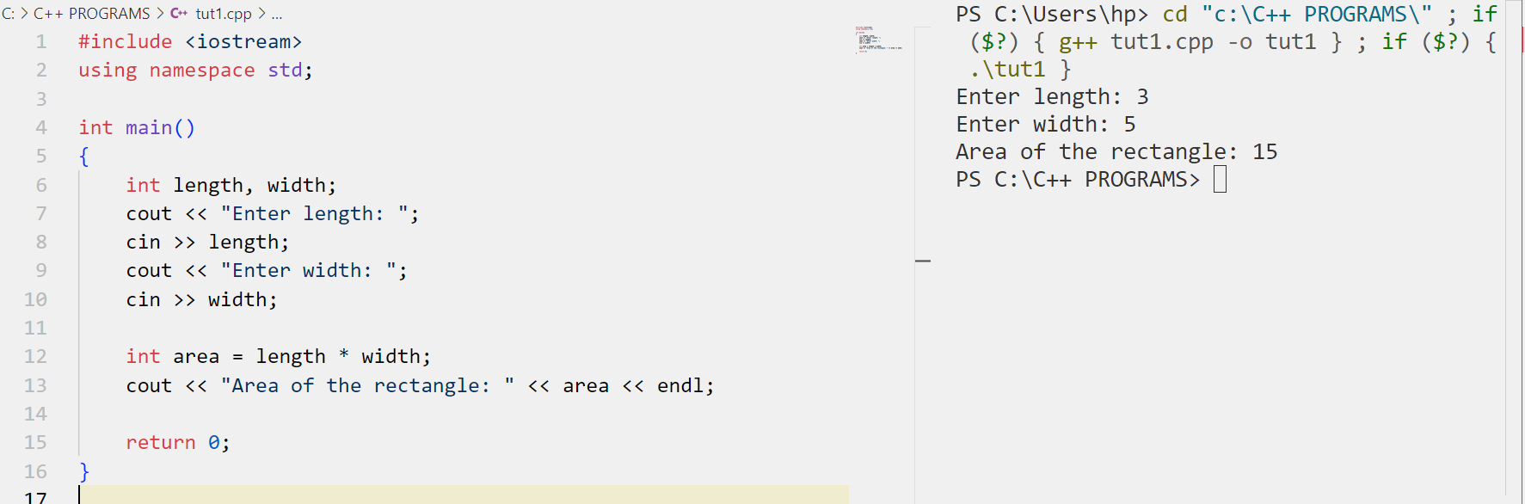

Question 2: Check Even or Odd: Write a C++ program to check if a given number is even or odd.
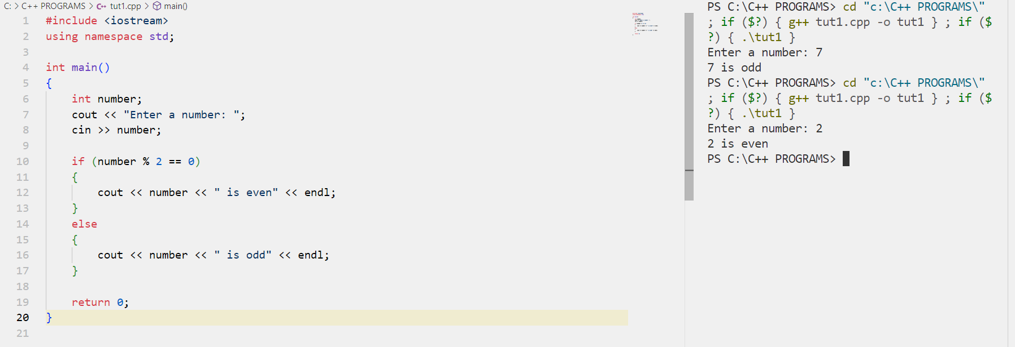

Question 3: Generate Fibonacci Series: Write a C++ program to generate the Fibonacci series up to a given number of terms.
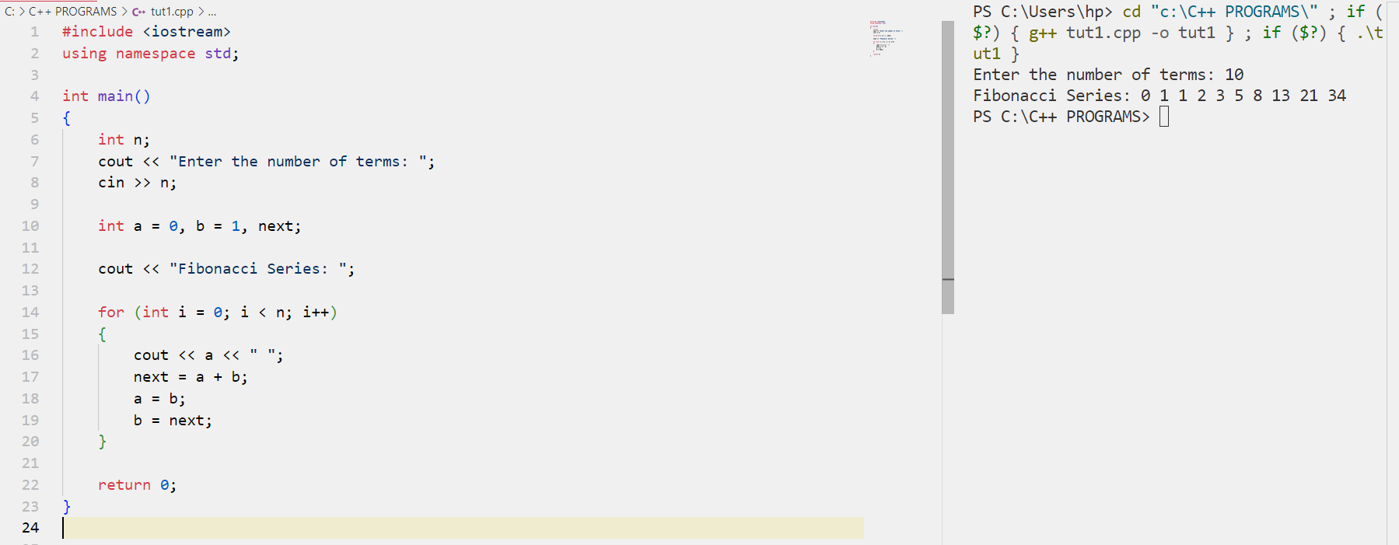

Question 4: Find Maximum Number: Write a C++ program to find the maximum number among three given numbers.
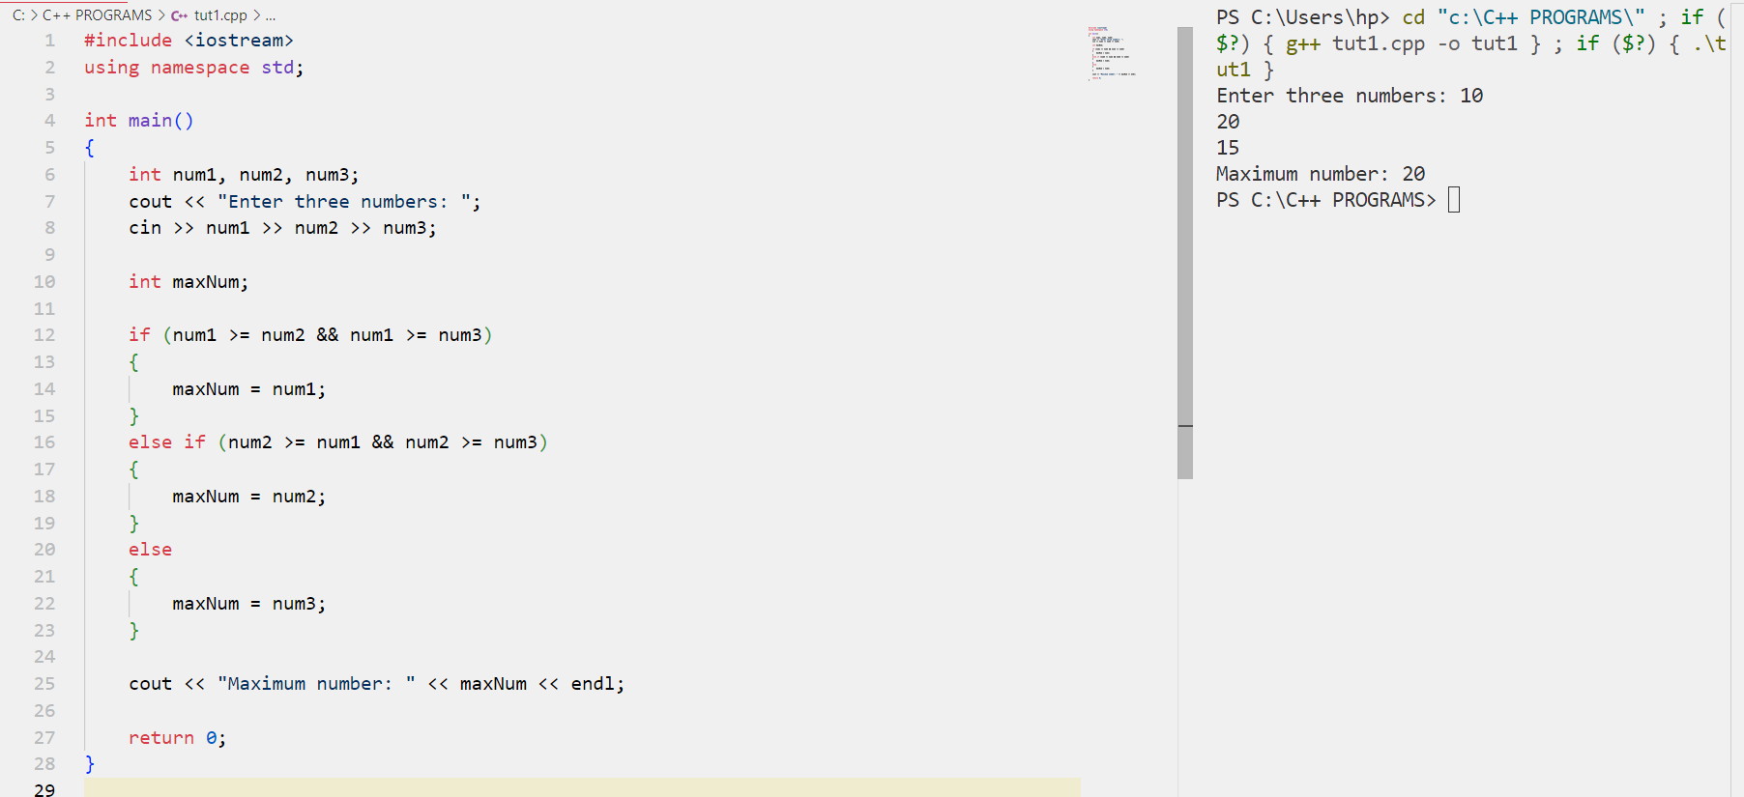

Question 5: Reverse a String: Write a C++ program to reverse a given string.
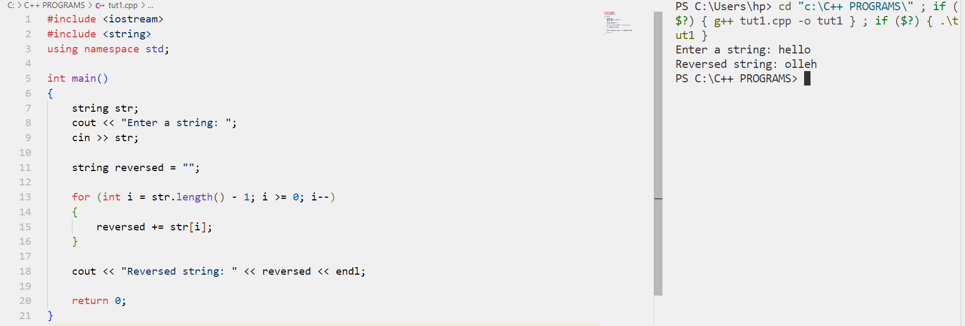

Question 6: Check Prime Number: Write a C++ program to check if a given number is prime or not.
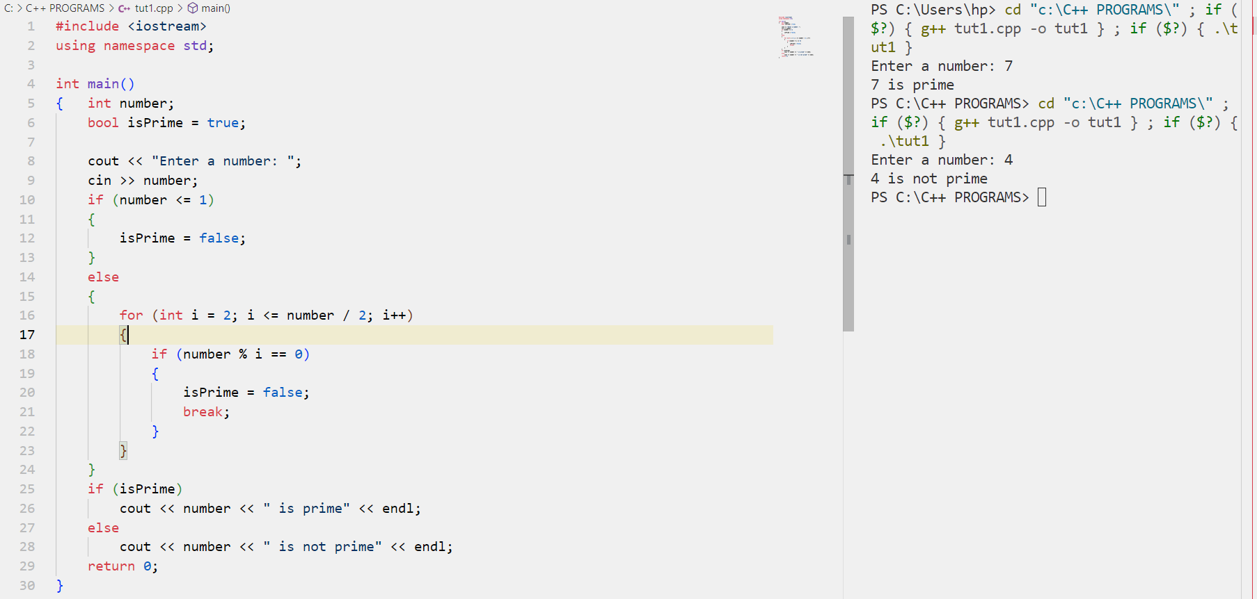

Question 7: Calculate Factorial: Write a C++ program to calculate the factorial of a given number.
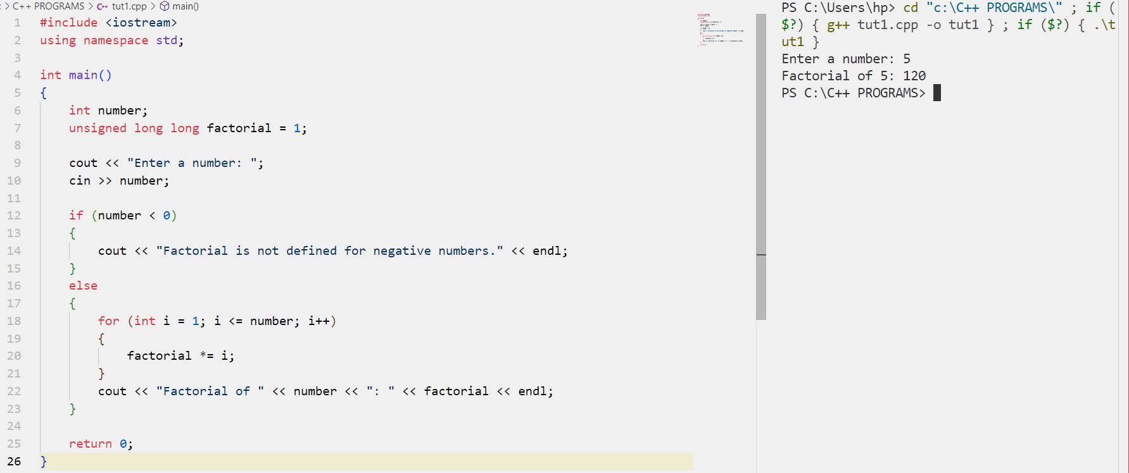

Question 8: Calculate Simple Interest: Write a C++ program to calculate the simple interest given the principal amount, rate of interest, and time period.
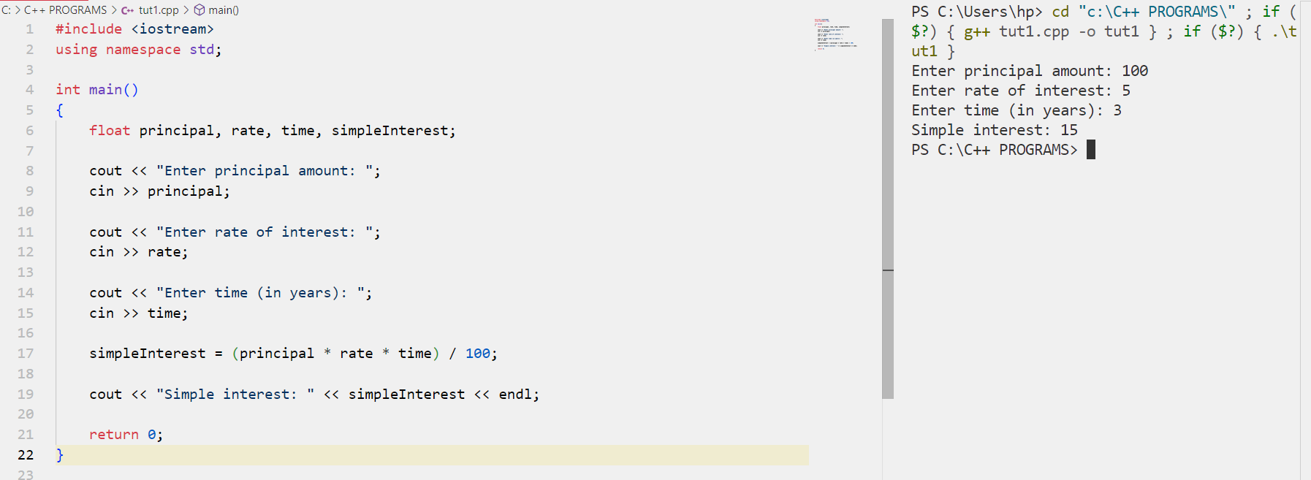

Question 9: Check Leap Year: Write a C++ program to check if a given year is a leap year or not.
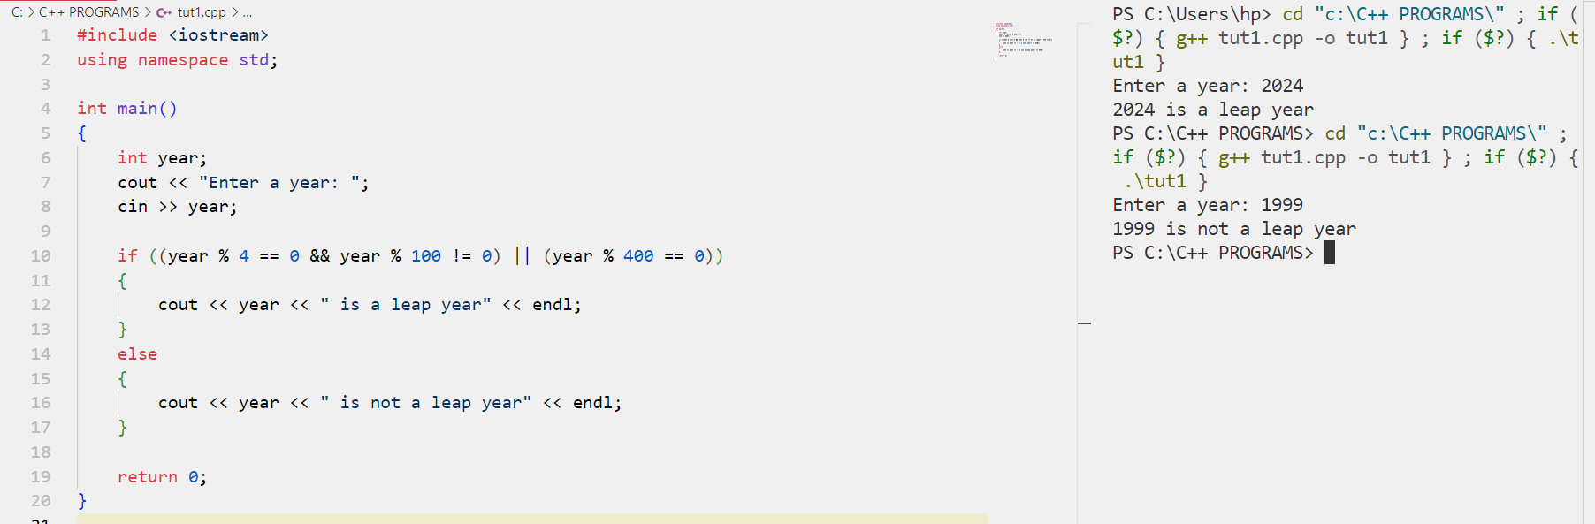

Question 10: Check Armstrong Number: Write a C++ program to check if a given number is an Armstrong number or not.
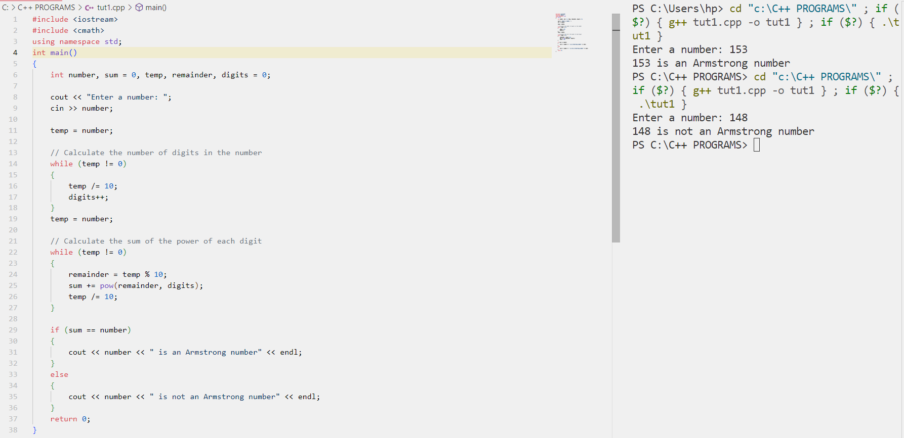

Question 11: Sum and Average Calculation: Write a C++ program that prompts the user to enter two numbers, calculates their sum, and then computes their average.
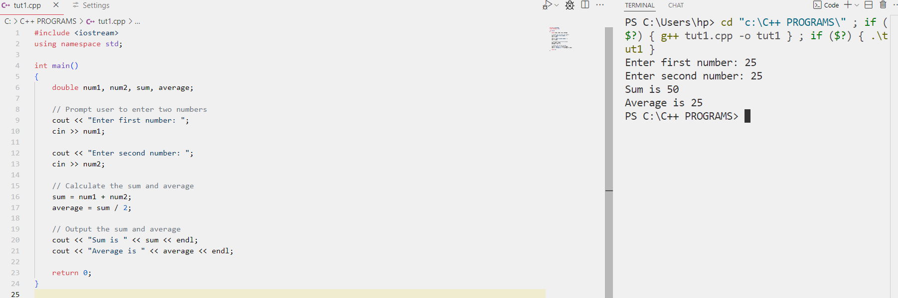

Question 12: Time Conversion: Write a C++ program that prompts the user to enter time in seconds and then converts it into hours, minutes, and seconds.
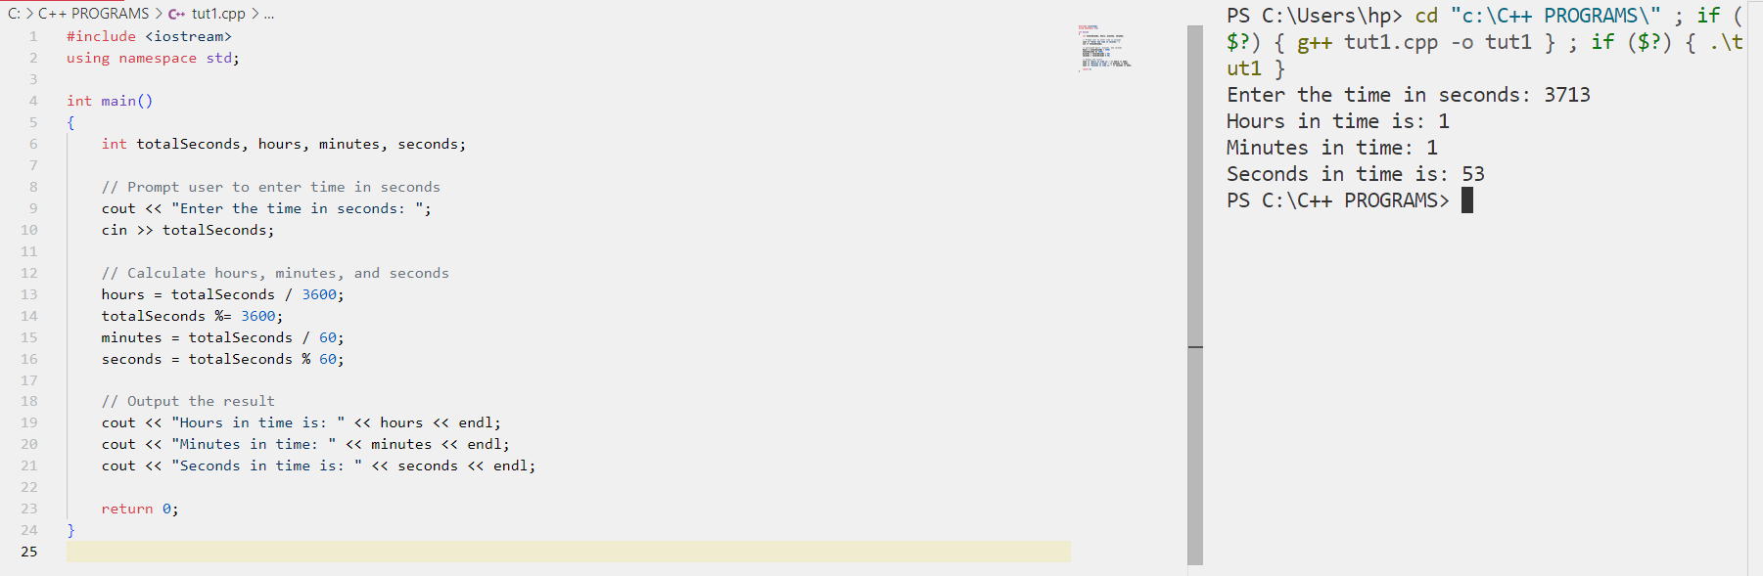

Question 13: Amount in Rupees Breakdown: Write a C++ program that prompts the user to enter an amount in rupees and then breaks it down into denominations of 1000s, 500s, 100s, 50s, 10s, 5s, 2s, and 1s.

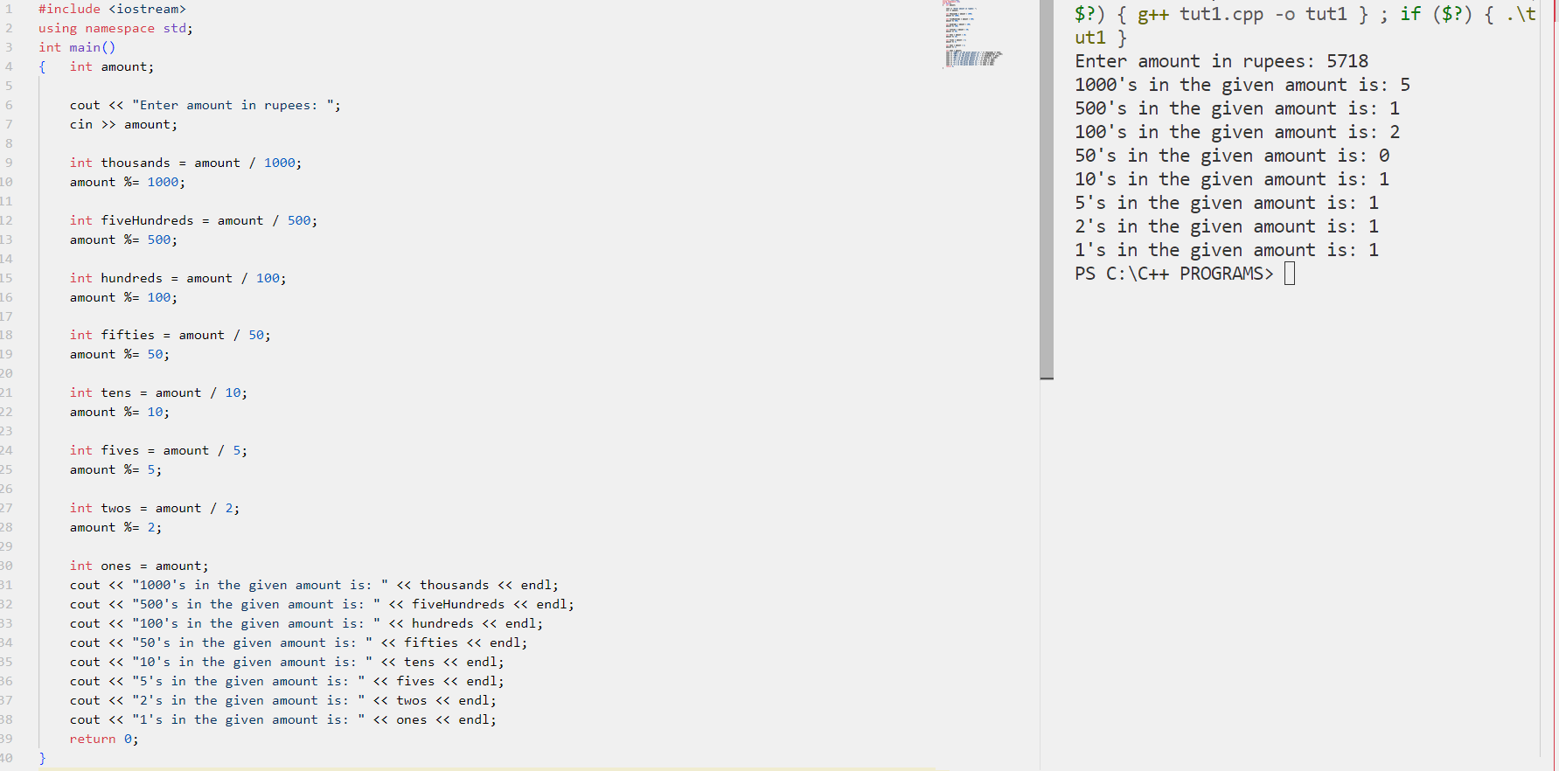

Question 14: Fahrenheit to Celsius Conversion: Write a C++ program that prompts the user to enter a temperature in Fahrenheit and then converts it into Celsius using the formula: Celsius = (Fahrenheit - 32) *5 / 9.
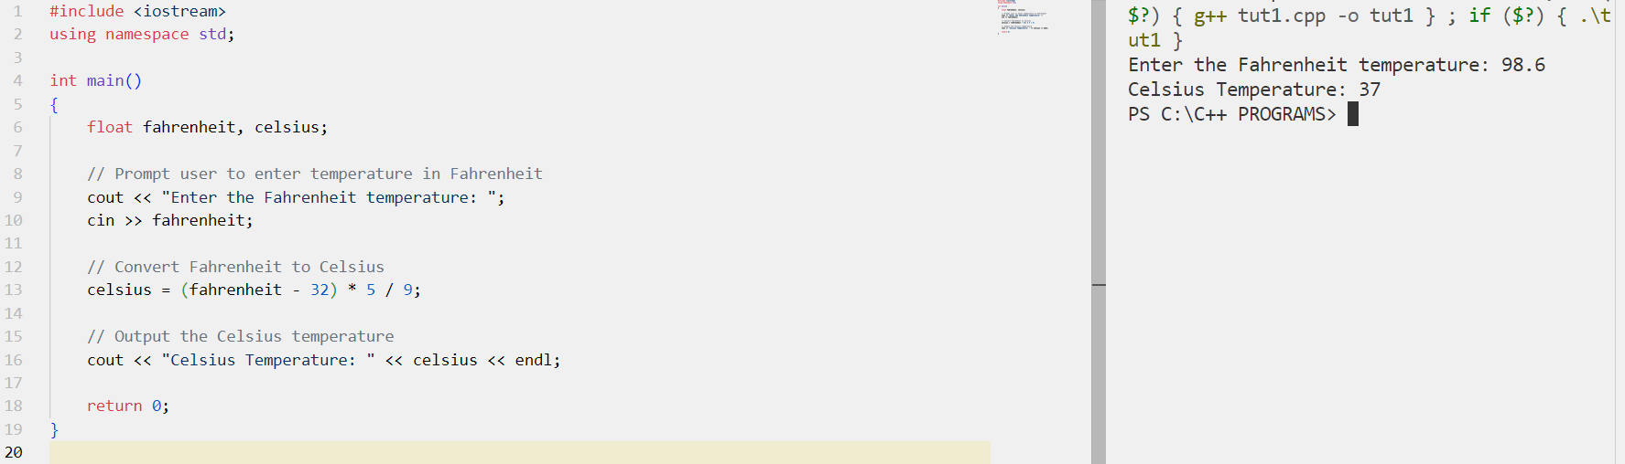

Question 15: Two-Digit Integer Reversal: Write a C++ program that inputs a two-digit integer value and outputs its reverse order.
